**WEEK-8 GIT**

**Exercise -5: Git – HOL**

1.Verify if master is in clean state:

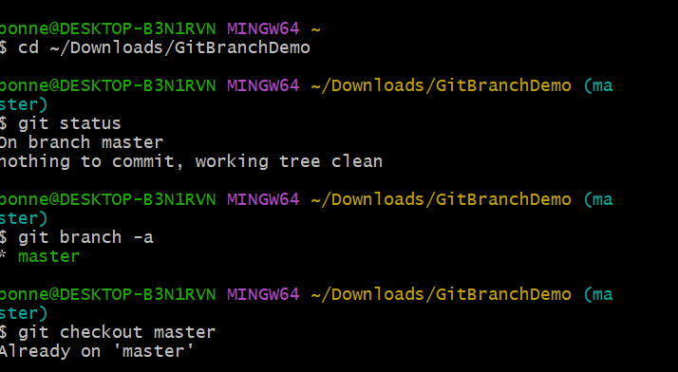

2. Pull the remote repository into master:

3.Push the Changes:

4.Verify changes in remote repository:

